Show the latitude and longitude along with time



Vehicle log entry and data entry page

Options menu page

The **Send all entries** will be used for sending the vehicle database to the employer and to clear the current database of any entries. If the **OK** button is pressed the **DialogProgress** class is used to send the email asynchronously in a thread and will show the progress of the action.

An email message is composed containing each vehicles' log entries during the **ProgressDialog** event using an Intent object and the built in Mail app. The username given in the preferences is to be contained on the first line of the email. Each Vehicle logger entry is put on its own line in the email,

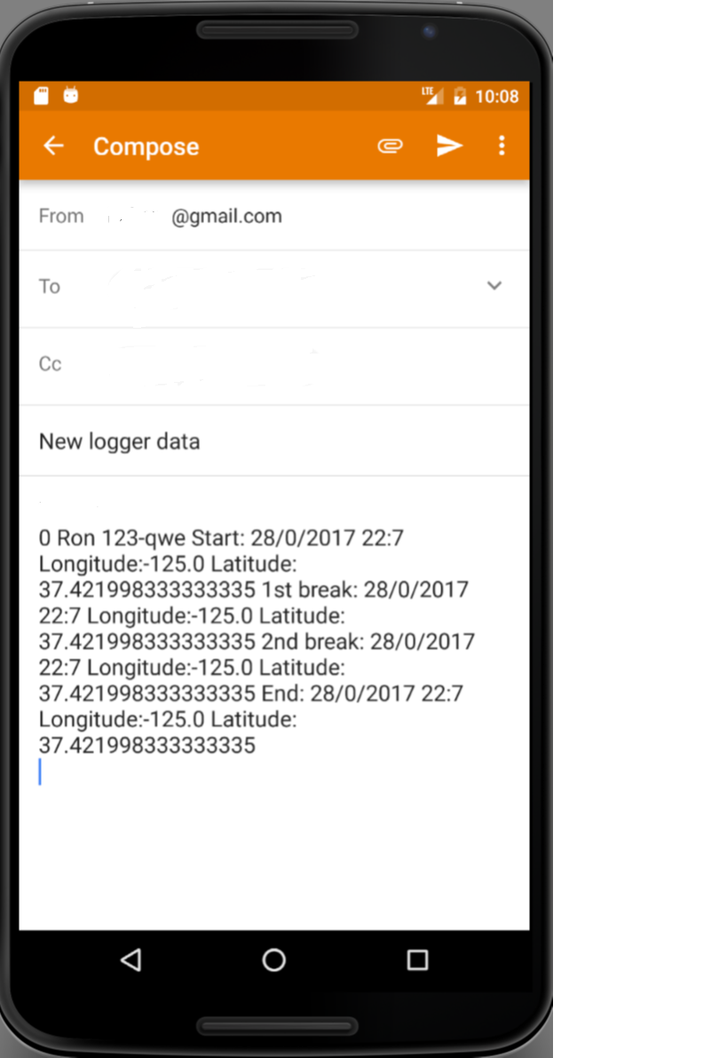

When the email is sent all the **Vehicle logger** database entries are deleted.